**10. ReactJS-HOL**

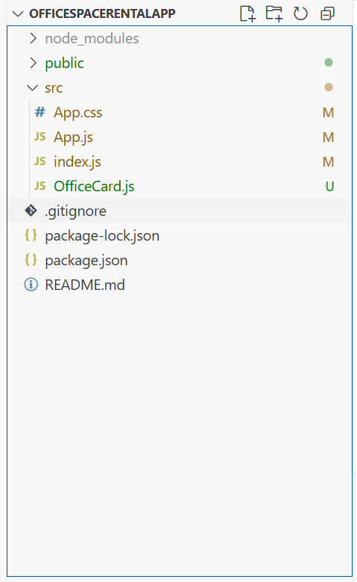

**OfficeCard.js**  
import React from 'react';

import './App.css';

function OfficeCard({ item }) {

  const rentColor = item.Rent <= 60000 ? 'textRed' : 'textGreen';

  return (

    <div className="card">

      <img

        src={process.env.PUBLIC_URL + '/' + item.Image}

        width="25%"

        height="25%"

        alt="Office Space"

      />

      <h2>Name: {item.Name}</h2>

      <h3 className={rentColor}>Rent: Rs. {item.Rent}</h3>

      <h3>Address: {item.Address}</h3>

    </div>

  );

}

export default OfficeCard;

**index.js**  
import React from 'react';

import ReactDOM from 'react-dom/client';

import App from './App';

const root = ReactDOM.createRoot(document.getElementById('root'));

root.render(<App />);

**App.js**  
import React from 'react';

import './App.css';

import OfficeCard from './OfficeCard';

function App() {

  const offices = [

    { Name: "DBS", Rent: 50000, Address: "Chennai", Image: "office.jpg" },

    { Name: "WeWork", Rent: 65000, Address: "Bangalore", Image: "office.jpg" },

    { Name: "Innov8", Rent: 55000, Address: "Mumbai", Image: "office.jpg" },

  ];

  return (

    <div className="App">

      <h1>Office Space , at Affordable Range</h1>

      {offices.map((office, index) => (

        <OfficeCard key={index} item={office} />

      ))}

    </div>

  );

}

export default App;

**App.css**.App {

  text-align: center;

  margin: 40px;

  font-family: Arial, sans-serif;

}

.textRed {

  color: red;

}

.textGreen {

  color: green;

}

.card {

  margin: 30px auto;

}

